TOPIC 2:BRUTE FORCE ALGORITHM
- List Examples
Aim: Demonstrate different types of lists.

Algorithm:
  - Create an empty list.
  - Create a list with one element.
  - Create a list with all identical elements.
  - Create a list with negative numbers and sort it.

Python code:
lst = eval(input("Enter a list: ")) if lst == []:
print("Output:", lst) else:
print("Output:", sorted(lst))

Input:
[]

Output:
[]
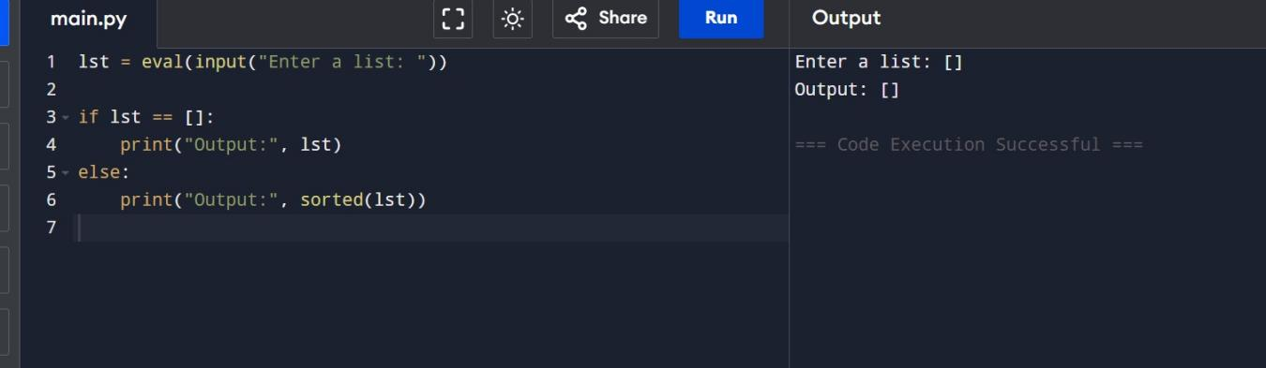

Selection Sort
Aim: Sort an array using Selection Sort.

Algorithm:
  - Divide the array into sorted and unsorted parts.
  - Find the minimum element in the unsorted part.
  - Swap it with the first element of the unsorted part.
  - Repeat until the array is fully sorted.

Python Code:
def selection_sort(arr): for i in range(len(arr)):
min_idx = i
for j in range(i+1, len(arr)): if arr[j] < arr[min_idx]:
min_idx = j
arr[i], arr[min_idx] = arr[min_idx], arr[i] return arr

arr = eval(input("Enter list to sort: ")) print("Sorted list:", selection_sort(arr)) Input:
[5, 2, 9, 1, 5, 6]

Output:
[1, 2, 5, 5, 6, 9]

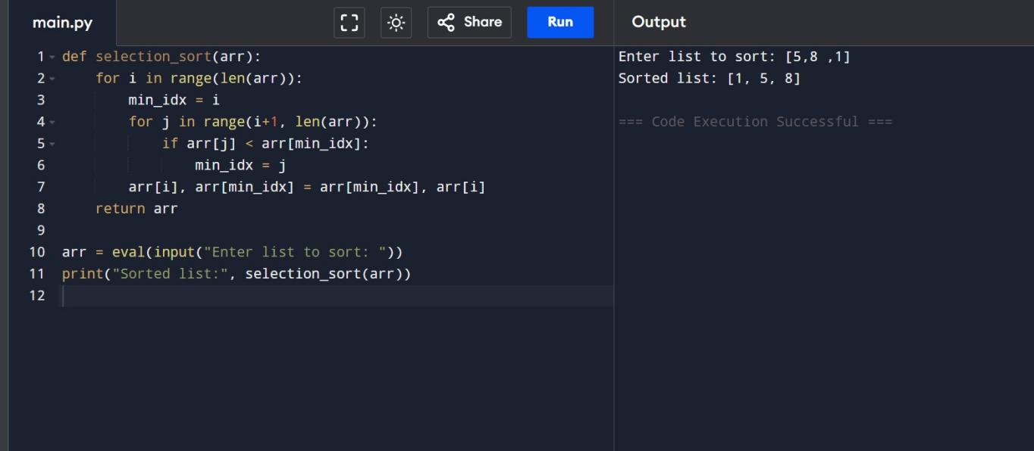

Optimized Bubble Sort
Aim: Stop Bubble Sort early if the list is already sorted.

Algorithm:
  - Compare adjacent elements and swap if needed.
  - If no swaps occur in a pass, the list is sorted.

Python Code:
def bubble_sort(arr): n = len(arr)
for i in range(n): swapped = False
for j in range(0, n-i-1): if arr[j] > arr[j+1]:
arr[j], arr[j+1] = arr[j+1], arr[j] swapped = True
if not swapped: break
return arr

arr = eval(input("Enter list to sort: "))

print("Sorted list:", bubble_sort(arr))

Input:
[64, 25, 12, 22, 11]
[29, 10, 14, 37, 13]
[3, 5, 2, 1, 4]
[1, 2, 3, 4, 5]
[5, 4, 3, 2, 1]

Output:
[11, 12, 22, 25, 64]
[10, 13, 14, 29, 37]
[1, 2, 3, 4, 5]
[1, 2, 3, 4, 5]
[1, 2, 3, 4, 5]

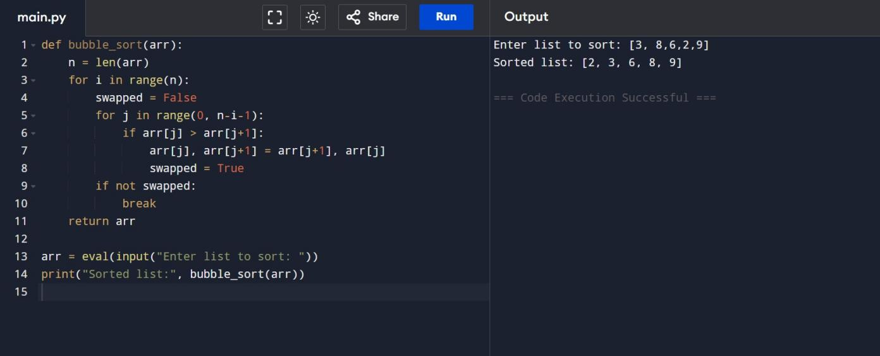

- Insertion Sort with Duplicates Aim: Sort arrays including duplicates. Algorithm:
  - Take one element at a time and insert it in its correct position in the sorted part.
  - Relative order of duplicates is preserved.

Python Code:
def insertion_sort(arr):

for i in range(1, len(arr)): key = arr[i]
j = i - 1
while j >= 0 and arr[j] > key: arr[j + 1] = arr[j]
j -= 1
arr[j + 1] = key return arr

arr = eval(input("Enter list to sort: ")) print("Sorted list:", insertion_sort(arr)) Input:
[3, 1, 4, 1, 5, 9, 2, 6, 5, 3]
[5, 5, 5, 5, 5]
[2, 3, 1, 3, 2, 1, 1, 3]

Output:
[1, 1, 2, 3, 3, 4, 5, 5, 6, 9]
[5, 5, 5, 5, 5]
[1, 1, 1, 2, 2, 3, 3, 3]

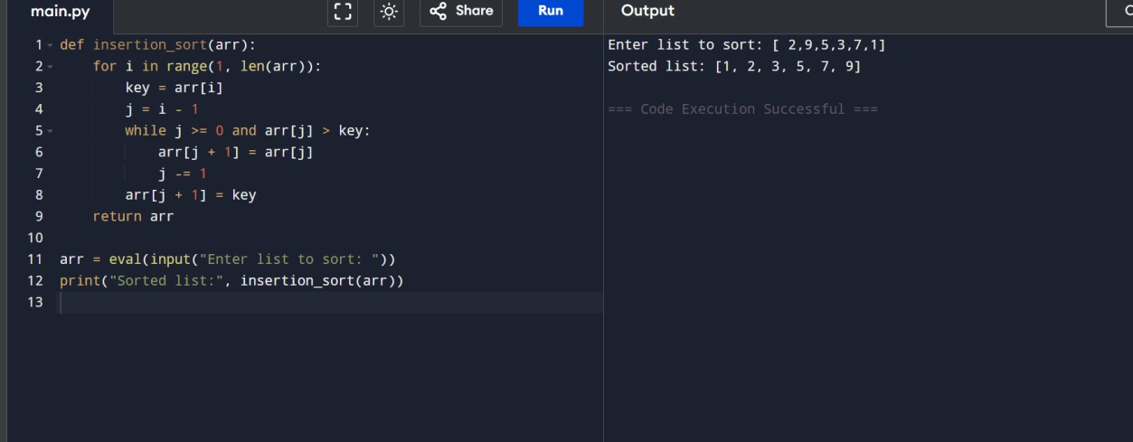

Kth Missing Positive
Aim: Find the kth missing positive number.

Algorithm:
  - Start from 1 and check each number.
  - Count missing numbers until k is reached.

Python Code:
def findKthPositive(arr, k): missing = []
current = 1
while len(missing) < k: if current not in arr:
missing.append(current) current += 1
return missing[-1]

arr = eval(input("Enter sorted list: ")) k = int(input("Enter k: "))
print("Kth Missing Positive Number:", findKthPositive(arr, k))

Input:
[2,3,4,7,11], k=5
[1,2,3,4], k=2

Output:
9
6

